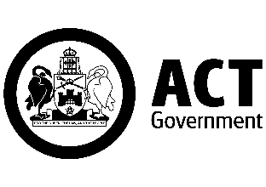

Dear Families
As promised, I am writing with additional information about the return of children to our school. campus. First, a reminder about the dates for our phased return.
Commencing 25 October  (Week 4) | - Early childhood centres (ECEC)  - Preschool and kindergarten  - Years 1 and 2  - Year 6  - Out of school hours care (OSHC)
Commencing 1 November  (Week 5) | - Years 3, 4 and 5
From weeks 1 to 4 of term, onsite supervision and care continues to be available for vulnerable children and young people whose parents are essential workers.
Drawing on national and local health advice we have developed a return to school plan which has three key priorities:
- the health and safety of staff and young people,
- the mental and emotional well-being of children and staff, and
- ensuring continuity of learning.
Below is an outline of ACT Health Guidelines that schools are required to implement to ensure effective COVID-19 measures are in place.
Use of Check in CBR app | All staff and visitors must check in using the ‘Check in CBR' app. Parents and carers cannot enter school grounds except for an essential reason. Visitors must call to make an appointment, or in advance of attendance. All visitors must report to the front office.
Student illness | Staff and students who are unwell are not able to attend school. Students who present unwell will be required to go home.
Hygiene | Schools will maintain and promote appropriate hand hygiene and respiratory hygiene practices. Students will need to wash hands and use hand sanitisers throughout the day. Students will not be allowed to share food or drink.

Masks | Staff and visitors must wear a face mask on campus. Students in years 3-6 are encouraged to wear a mask if they are comfortable doing so. Students in Preschool to year 2 are not required to wear a mask. If a P-2 child arrives to school in a mask they will not be asked to remove their mask. Masks may not be suitable for students with a disability or medical condition and schools will make allowances for those students not to wear masks.  * Students will be required to wear their personal masks. Masks will be available at school for those who require them. Disposable masks need to be changed every four hours.
Physical Distancing | Physical distancing between children and young people is not always possible, particularly in single classrooms and school environments. It is however important for limiting the transmission of COVID 19. To promote physical distancing we will adjust learning programs, breaktimes and our timetable as well as pick up and drop off arrangements. More specific information about what this means for your child is included below.  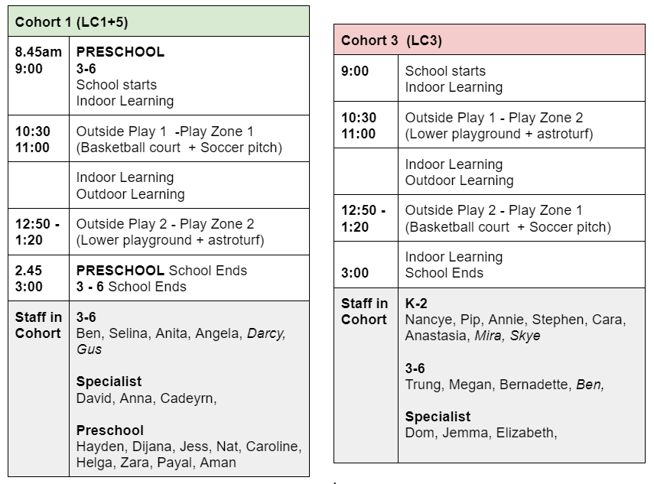  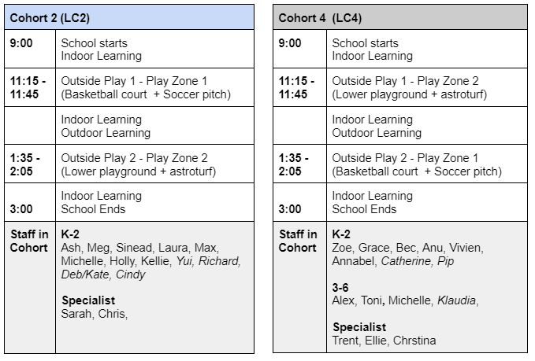
Environmental cleaning | Our school cleaning program includes regular cleaning of high touch surfaces and frequently used objects continuously during the day. Our BSO, Chris, will clean the play equipment after each use.  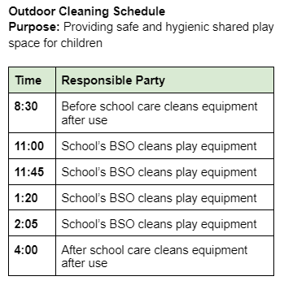
Ventilation | All schools have been assessed to increase fresh air circulation and this may involve changes to ventilation, modified HVAC system settings and maximising the use of outdoor learning spaces. As a new school, we do not require any modification to our ventilation system.
Managing suspected cases | We are prepared to respond to a positive COVID-19 case on campus, should the need arise. ACT Health will provide direction to the school and community, which may result in a full or partial school closure. A student who presents with symptoms of COVID-19 will be isolated with suitable supervision, and parents will be required to collect their child immediately. Symptomatic students will be required to wear a mask. Families are asked to send through the results of a negative COVID test to the school email prior to the child’s return to school.
Will schools have routine testing for COVID-19? | Anyone with COVID-19 symptoms should get tested immediately. ACT Health is not recommending routine COVID-19 testing of children, young people  or staff using rapid antigen testing.
Wellbeing supports | Face to face wellbeing and learning supports, such as face to face appointments with the school psychologist or access to a Learning Support Assistant, will recommence with the return to school.  For parents and carers of students with a medical vulnerability: if you wish the school to make reasonable adjustments for the safe return of your child, you must consult a GP and provide medical advice to that effect. Where adjustments can’t be made, the school will support your child to learn from home.  Teachers/Learning Coaches are scheduling google meet check ins with families from their home learning group next week. From here, they will schedule personal phone calls as required to develop a transition support plan to ensure a smooth and considered return for every child to face to face learning.

To further support the ACT Health Guidelines our school is making the following adjustments.
Drop off and pick up | The drop off and pick up points and times were discussed with families at the Community Forum held on Wednesday 13 October. Family feedback and input was used in the formulation of the plan outlined below. No members of family/community are allowed to enter the school grounds.  Preschool  - Preschool start and finish times will be adjusted to ease congestion during peak times.  - Preschool will start at 8.45 and end at 2.45  - Preschool children will meet their teachers/learning coaches at the bottom gate between 8.40 and 8.45  - Preschool teacher/learning coaches will meet families at the bottom gate at 2.45pm  K-6  - Children in Year K-6 will enter through the bottom gate and the gate leading on to the High School site  - Children in Year K-6 will exit through the bottom gate and the gate leading on to the High School site  - Children will move directly to home learning coach group lines prior to moving in to the learning community.  Before and After School Care  - Children attending before and after school care will enter and exit through the bottom gate.  - Further information regarding the arrangements for drop off and collection will be provided to those enrolled in the program directly  Children arriving on wheels (bike/scooter)  - A member of staff will check the wheels in and out of the bike shed each day upon arrival of children. The member of staff will be at the bike shed from 8.50am.  Children/Family members with additional needs  If your child has specific additional needs, or the family member accompanying them to school has specific additional needs, a personalised plan will be put in place to meet the individual needs.  Parking  The drop off zone directly outside the administration building will not be used for general pick up at this time. This is to support families who have children with additional needs, or have additional needs themselves to access this space to drop off and pick up their children through a hand over hand approach. The people accessing this service will be negotiating directly with the principal.  People are encouraged to walk/ride to school and access the large carparking facilities at the back of the oval.  A visual map is attached to this email for easy reference. Families who would like to discuss personalised arrival/departure plans are requested to email the school inbox.
Hygiene routines | Hand sanitiser will be located upon entry to each learning community. Hand sanitiser will also be located in strategically located spots throughout the learning community to allow access throughout the school day.  Children will be asked to sanitise/wash hands upon arrival. It is acknowledged that some children are sensitive to hand sanitiser and accommodations will be made to support these children to use the hand washing facilities upon arrival and throughout the day.  Hand washing will be required prior to eating, prior to movement within the learning community, prior to going to outside play, and again when returning from outside play.  Signage regarding best practice for handwashing that is age appropriate has been laminated and placed in each bathroom. Teachers/learning coaches will remind children throughout the day of key hand washing/sanitisation points.
Teaching and learning | To reduce movement and interaction throughout the day amongst children and staff, we will cohort children according to learning communities. Children will remain within their learning community for the duration of each day and will not leave the community for specialist lessons. Outdoor play breaks will be staggered throughout the day and will be observed in learning community groupings.  Specialist teaching staff (music, PE, drama, library, STEM) will create online lessons for children to engage with, similar to what they have been producing during remote learning. This will prevent the need for specialist staff to move in and out of learning communities throughout the day. This approach will also ensure that all children will retain access to specialist subject areas from within their learning community.  The library will not be open for borrowing during this time. Comprehensive libraries of books will be available in each learning community. Any family wishing to return library books will follow the COVID safe return protocols as advised by the teacher librarian.  Specialist teachers/learning coaches will be assigned to each learning community. This will remove the need for these members of staff to move throughout the school over the course of the day/week. This will limit interactions with children/staff to one learning neighbourhood only.  Break time clubs will not be able to continue at this time.  Communication  All communication will come out in a cascading approach. On Wednesday 13 October, a Community Forum was held with the Principal to discuss and ascertain common wonderings on the return to school. This information has informed the return to onsite learning plans.  Ongoing communication can be expected through the following methods:  - Community Forum and P&C Meeting Wednesday Week 3  - High level information through email/seesaw accompanied by video vignettes to outline key information to families in English and Tamil.  - One page infographic of key information will be provided to families regularly following each principal update  - Family google meets with home learning coach/teacher  - Phone call/google meet with individual families as required  - Seesaw updates from learning coaches/teachers  - ‘letter to the child’ detailing what to expect upon return will be posted to seesaw prior to 25th October. This will be accompanied by a video to support children to visualise any changes to their normal routine and promote confidence and certainty in their return to the school site.
Break times | Each Learning Community will have play breaks at staggered times. Play equipment will be cleaned between each playtime with approved cleaning products.  The cohorts for play break purposes were detailed earlier in the ‘Physical Distancing’ section. Children will be allocated different play areas within the school grounds for their breaks to enable the cleaning of play equipment between learning communities.
Before and After School Care | The staff from Woden Community Services will provide detailed communication to families through their regular channels of communication to outline what cohorting will look like during before/after school care.
We will continue to review and adjust these measures based on the most up to date advice from ACT Health.
Remember, all adults and children aged 12 years and above are eligible for vaccination. If your child is eligible but not yet vaccinated, we encourage you to book them in by calling the COVID-19 vaccination line on 5124 7700 daily between 7am-7pm. Bookings can also be made with some GP clinics and pharmacies.
We understand that there has been considerable change and uncertainty for our students during the pandemic, and as we transition back to school. I’d remind you that you and your child can book an appointment with our Telehealth Support Service on 02 6205 1559 between 9.00am and 4.30pm weekdays. With the return to school, your child will also be able to organise face to face sessions with the school psychologist.
For more information about the return to schools, I’d recommend visiting the Education Directorate’s website.
You can keep up to date with the latest health information, advice and resources on the ACT’s COVID-19 website.
I would also like to take this opportunity to thank you for your support and understanding as we return to face-to-face schooling.
We look forward to seeing all our children back at school.
My regards,

Kate Woods
Margaret Hendry School

